Two of our Trustees, Andrew Schneidau and Alan Ball, visited the East Coast of Sri Lanka for a couple of weeks at the end of July with Alan’s son, Elliot, and three of his friends Gerard Wiley, Jordan Titmus and Simon Dumont. This is their update on our projects…
The “Little Flowers” after-school facility for children in Thirikuvil

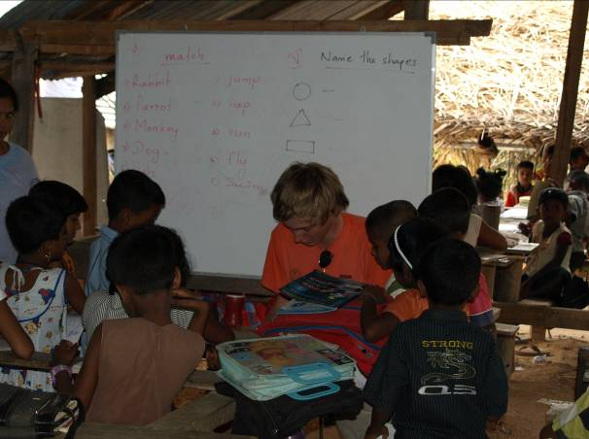
As mentioned in our last newsletter, HELP has set up after-school classes for junior school children in Thirikuvil, which the Principal, Mr Gunapalan, has named “Little Flowers”. It continues to be an unqualified success with over 150 of the poorest children in the village attending 2-hourly classes in Tamil, Singhalese, English, Maths and Social Science from Monday to Thursday each week. HELP provides the funding for the school’s equipment and pays the salaries of the seven teachers (total cost c£150 per month).

We were again privileged to attend the end of year prize-giving and handed out exercise books and pencils/pens to all the children (in exchange for some beautiful hand-made garlands). We agreed to increase the teachers’ salaries by £5 per month each (to £20) but a bigger concern for us is the school itself. The makeshift school was built on land adjacent to Mr Gunapalan’s house, but the owner has asked for it to be returned to build a house as a dowry for her daughter. The school will therefore need to be relocated and rebuilt. Mr Gunapalan has identified some land in his street and estimates the total cost of land purchase and school rebuilding to be in the region of £3000. We committed whilst on the visit to fund the land purchase and rebuilding and are now actively fundraising to meet this commitment. All donations will be most gratefully received...

Swami Vipulananda Boys’ Home
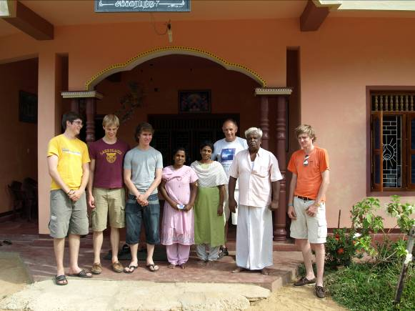
One of our most longstanding projects has been supporting the Swami Vipulananda Boys’ Home in Akkaraipattu, which provides a safe haven to 35 boys orphaned by the tsunami and the civil war. Times continue to be very difficult for the Home. The Principal, who does an extraordinary job in difficult circumstances, has been seriously ill (although he made time for us on our visit) and other sources of funding for the Home have fallen away. We provide the Home with a monthly bursary of c£200 but this only meets half its regular outgoings for food, clothing and other expenses. We will increase the bursary as and when our funds permit and, whilst on the visit, we were delighted to be able to buy a wide array of equipment for the Home including clothes for the boys, a full complement of new kitchen equipment (pots, pans, rice cooker, ladles etc), books, bedding and sports equipment. There was a very moving ceremony with the Principal, his staff and the boys when we handed this equipment over.
Amman Mahaleer Girls’ Orphanage
We visited the Amman Mahaleer Girls’ Orphanage in Akkaraipattu on a number of occasions during the visit and met Sharmila, the Principal, her dedicated staff and, of course, the girls. Notwithstanding the hardships they face, it never ceases to amaze how cheerful they appear. HELP has been supporting the orphanage for the past four years. When we first visited back in 2005, the girls were sleeping, eating meals and having lessons on the floor of the home. In the early years, we were pleased to be able to provide chairs, tables, beds and mattresses for the orphanage, school socks and shoes for the children and equipment for the kitchen. Two years ago, we undertook to build a kitchen and dining area for the girls as the existing facilities were not fit for purpose. We were delighted to see on this trip that the building had been completed and was being used to the full. We bought additional chairs and tables for the orphanage and some new kitchen equipment, including a gas cooker and cylinder. Last year, we paid for the orphanage to be connected to the electricity system and this has been a great benefit to the girls who can now study in the evening and take computer classes at weekends (although two of the Home’s four computers need repairs which we will fund).
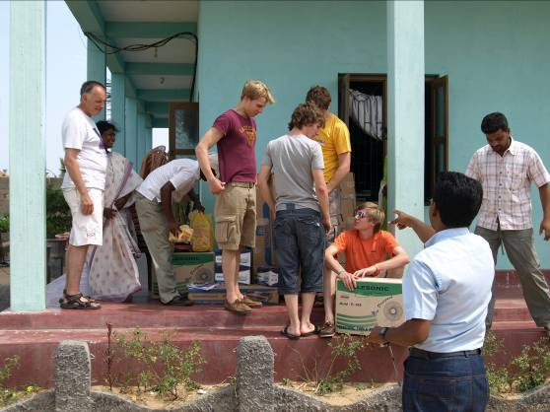
The orphanage is struggling to meet its ongoing expenses. As with the Swami Vipulanda Boys Home funding has fallen away and the Principal and her team need an additional c£150 per month to meet their monthly costs for the 56 girls. We don’t have the funds to meet this shortfall but will aim to set up a small monthly bursary for the Home.
Komari Garden Project
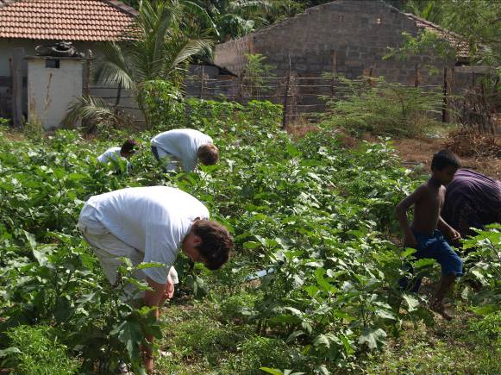
Ahead of the visit, the boys raised a substantial sum of money from fundraising at their school, King Edward VI Grammar in Chelmsford, to set up a community-based garden project in Komari. Working with our colleagues in Komari, Wilfred and Santhan, ten single-mother families have been identified as participants in the scheme. The project involves clearing land around the house of the family, providing irrigation and seeds and then growing cash crops which the family can sell in the local market. Preparation of each ‘allotment’ costs in total c£125 and the construction of wells a further £300. The boys spent a (very hot!) morning clearing a patch of land for one of the families, much to the amusement of the local children. But this is a very worthwhile project providing sustainable livelihoods to some of the poorest families in the region and their efforts were genuinely much appreciated. The boys hope to return next year to see how the project is progressing under Wilfred and Santhan’s management.
Micro-finance schemes in Komari, Pottuvil and Urani
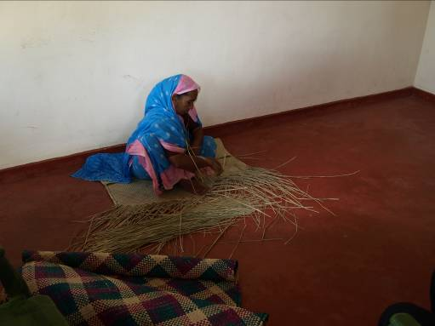
We currently fund 3 small micro-finance schemes in the villages of Komari, Urani and Pottuvil. These schemes provide very small loans to a total of 65 single mothers which gives them the opportunity to start their own businesses. During the visit, we were privileged to be able to visit four of the women that have benefited from the scheme, each of which had made use of the small loans to set up different businesses. These covered mat weaving, curd making, dress making and chicken breeding. Two of the women we met had been involved in the micro-finance scheme for a period of 3 years and it was clear that it had transformed their lives. We are very happy to continue to support these schemes which are run locally by colleagues in Relief International at no cost to HELP.
Komari School Educational Scholarship Scheme
As we have mentioned in previous newsletters, we are running an educational scholarship scheme at Komari school which provides the opportunity for able students to pursue A level studies. (State provision of education is only funded to GCSE level.) Whilst on the visit, we met the Principal of the school and were delighted to hear that the scheme continues to go from strength to strength - he mentioned that one of our former students recently completed a degree in dentistry. There are currently 54 students taking A levels under the scheme and there will be more joining the scheme in September. Next year, the Principal is going to insist that the students benefiting from the scheme devote some time each week to teaching juniors in the school. We fully support this initiative. We are grateful to the Amman Temple in West Ealing for their continued support for this scheme.
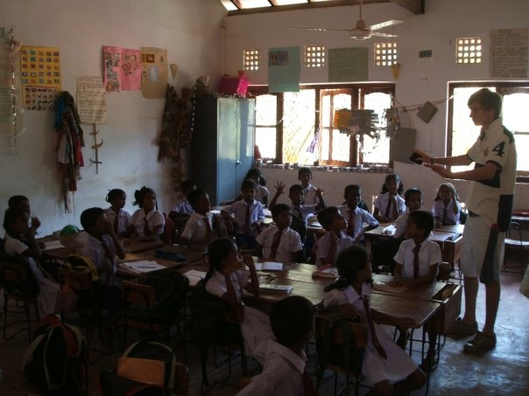
Elliot and his friends spent some time during our visit teaching English and volleyball (or were they being taught??) to the juniors of the school and at the end of the two weeks we were very happy to donate some badly needed sports equipment to the school.
Ampara Safe House
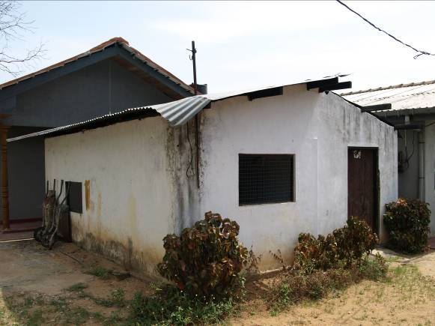
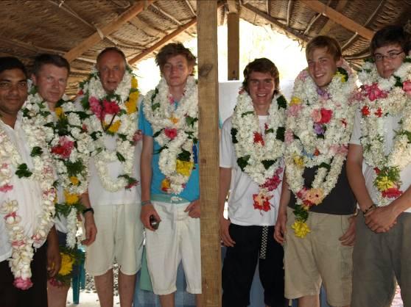
Before the trip, we had been informed of the plight of a children’s safe house in Ampara and had been asked if we would be prepared to support it. The safe house provides a temporary (6 week) refuge for abused children who are made wards of court prior to being found more permanent places in children’s homes. It is a sad fact that domestic abuse occurs but it is positive to note that the local community is actively trying to provide support. The safe house can accommodate a total of 12 children at any one time. We visited the property and were distressed to see the lack of basic facilities available; cramped rooms, no bedding, toys or clothes and only basic kitchen equipment. The previous funding of the Safe House had fallen away and its ongoing costs (food/utilities) were being met on a temporary basis by a local charity. We met the Warden of the House and recognized that she was doing as good a job as possible in very difficult circumstances. We are not in a position to fund the Safe House’s ongoing expenses but we committed to buy the necessary bedding, clothes, toys etc for the children from our current resources. The house desperately needs a small playground for the children (swings, roundabouts etc) at a cost of £500 which we will endeavour to support from future donations as and when funds permit.

We hope the above has been of interest and gives you some indication of where your generous donations are going. As you will be aware all donations received go directly to the projects and causes which HELP supports - there are no administration or operating costs charged to the charity.
If you would like any further details about HELP or on any of the individual projects, please do not hesitate to contact us at drvipt@yahoo.co.uk. Please note also that our website (www.helpingeastlankaprogress.org.uk) has recently been updated and includes a full set of photos from this and previous trips.
With thanks again for all your continued support.
Dr Vip Thiagarasah
Mrs Viji Viyakesparan
Senny Viyakesparan
Alan Ball
Andrew (Pug) Schneidau
Elliot Ball/Gerard Wiley/Jordan Titmus/Simon Dumont
September 2009

HELP is registered with the Charities Commission in the UK number 1111363.

