

**ANNUAL REPORT 2024**

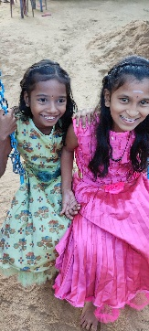The economic situation in Sri Lanka has remained precarious over the past year with fuel and basic food prices remaining high. This has continued to create difficulties for the poorer sections of society, including in the East of the island where HELP focuses its attention. Our Treasurer visited our ongoing projects in December 2023 and was impressed, as ever, by the commitment of the management and staff of both the Amman Mahaleer Girls’ Home in Akkaraipattu and the Little Flowers school in Thirrikuvil. Given the circumstances, they continue to do amazing work with the vulnerable and less privileged children in their communities. We have been delighted to continue supporting their needs as and when required throughout the year thanks to your generosity.

**Amman Mahaleer Girls Home**

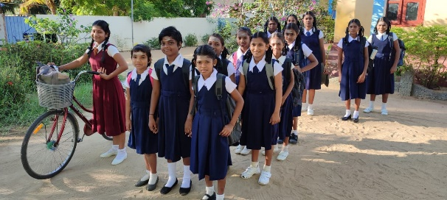HELP has supported the girls’ orphanage in Akkaraipattu for over a decade. The Home provides a safe haven for 50 young girls and ladies aged between 5-20 and assists in providing vocational experience to the girls through a dressmaking and computer facility that we were happy to establish in 2012. In December 2023, the Principal of the Home requested funding for new clothes and school equipment for the girls. Thanks to your generosity, we were delighted to be able to meet this request. The photo shows the girls in their new school clothes.

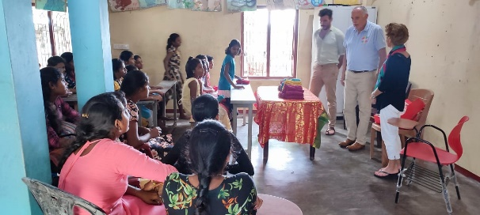During the course of their visit, our Treasurer and family friends were delighted to present some small gifts to the girls and join them in a small celebratory party.

The increase in basic running costs of the Home has created difficulties for the Home and we were very happy to increase our monthly bursary from Rps150,000 to Rps 200,000 mid-year to help out. In addition to contributing to the Home’s maintenance costs, including food and fuel, it also pays the salaries of the teachers in the vocational centre. We have also continued this year to meet the university fees of four young ladies from the Home. Gaining a university place is an incredible achievement by these young ladies and testament to the wonderful support they have been given by the Home.

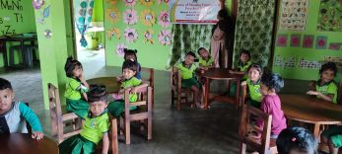**Amman Lotus Pre-School**

HELP has provided significant funding and support to the Lotus pre-school, situated in the grounds of the Home, over the past decade. The pre-school provides nursery and primary education for children in the local village. We were pleased to provide new wooden tables and chairs for the children this year and our Treasurer and his friends were delighted to take part in the Grade 5 pupils’ graduation ceremony to secondary school last December.

**The ‘Little Flowers’ school in Thirrikuvil**

HELP set up an after-school teaching facility in 2008 in the small village of Thirrikuvil at the request of Mr Gunapalan, a lecturer at a local university who was instrumental in providing assistance to our Trustees at the time of the 2004 tsunami. The school was forced to close during the Covid pandemic, but we are delighted to report that it has now reopened and is shortly to expand with a second facility being built in the adjoining village of Thandiyadi. We were very happy to provide the funding for the building of the new facility and to equip it 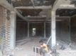with new whiteboards, benches and school equipment. Over 100 children regularly attend the school in Thirrikuvil each evening to study English, Mathematics, Tamil and Social Science to complement their state school lessons. Similar course are planned in the new school in Thandiyadi. As we have reported in the past, these additional lessons have had a marked impact on the educational performance of the children from these small villages, with a number of pupils achieving sufficient grades to take up university places.

Finally, we would like to say a huge thanks to David Bishop and his company, FrontMedia, who kindly updated our website during the year at no cost. Please do have a look if you get the chance - [*www.helpingeastlankaprogress.org.uk*](http://www.helpingeastlankaprogress.org.uk).

HELP remains a very small charity with a focus on the wellbeing of vulnerable and less privileged children in a very deprived region of the country. We hope the above has been of interest to you and thank you again for your continued support throughout the year.

**Summary Financial Position**

We thought it would be helpful to provide a summary of HELP’s income and expenditure for the past twelve months (1 November 2023 to 31 October 2024):

**Income (£)**

Bank Balance b/f (1/11/23): 8,165  
Donations 11,087  
**Total** £19,252  
  
**Expenditure (£)**

Bursary to Amman Home 5,163  
University studies 860  
New clothes and equipment 1,325  
Pre-school chairs/tables 702  
Little Flowers building work 403  
Little Flowers equipment 316  
Just Giving fees 216   
Annual bank charges 284  
**Total** £ 9,269

**Bank balance c/f (31/10/24): £9,983**

If you wish to make a donation to HELP, our website has a JustGiving page or direct bank transfers can be made to our account with the Bank of Ceylon (UK) Ltd. The bank details are as follows:

Bank: Bank of Ceylon (UK) Ltd   
Name of account: Helping East Lanka Progress  
Sort Code: 40-50-56  
Account number: 88001077

Thanks again and best wishes to all.  
  
Dr Vip Thiagarasah (Chairman)   
Mrs Viji Viyakesparan (Secretary)  
Andrew Schneidau  
Senny Viyakesparan   
Alan Ball (Treasurer)  
  
November 2024   
  
*HELP is registered with the Charities Commission in the UK - number 1111363*